Table of Contents

Lec#1: Why Study Algorithm & What’s in this section?

Might be trying to find:
- singularity
- shortest path
etc. Problems like this.

Find Improvements:
- Running Time
- Space Occupancy

Artificial Intelligence:
- Not clearly defined problems
- Translations
- Object Identification
We don’t actually understand the fundamental difference between these things or how to identify or differentiate between these.

This Course’s Focus:
- Clearly defined
- Hard to do efficiently

Coming up:
1. Fibonacci Numbers
2. Greatest Common Divisors

Problem Statement ----> Algorithm

So, here is what we are looking for in an Algorithm:
- Slightly complicated Algorithm that works fine
- actually incredibly fast.

Lec#2: Naive v/s Efficient Algorithm – Fibonacci Numbers

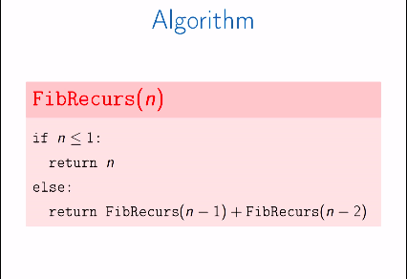

- T(n) = 2 n<=1
- T(n) = T(n-1)+T(n-2)+3 else

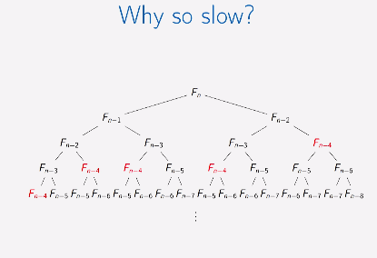

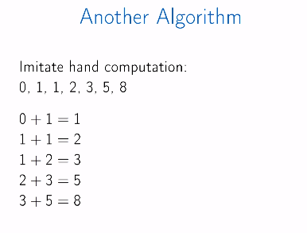

- T(n) = 2n + 2
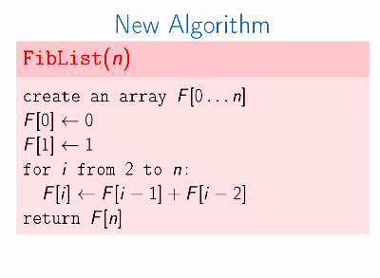
- Easy to compute

